Science & Technology Department

Interamerican University of Puerto Rico

Aguadilla Campus

XYZ Company

Manual 2026

Ektor M. González Ramos

A00617167

COTN2122.NETWORK ADMINISTRATION II

May 13, 2026

Prof. Samuel Rodriguez Roman

Table of Contents
- Active Directory Introduction
1.1. Overview
1.2. Users
1.3. Groups
1.4. Group Policies
- Getting Started
  - Users
    - Creating Users
    - Adding Users Information
  - Groups
    - Creating Groups
    - Changing Groups Scope
  - DNS, WINS, and DHCP
    - DNS
      - Creating DNS zones
      - Creating DNS record
    - WINS
      - Configuring DNS
    - DHCP
      - Configuring DHCP scope
      - Configuring reservations
2.4. Computers
2.5. Group Policy (Linking, General, Security, File System, Software Deployment)
2.6. Validating the Implementation
2.6.1. Using GPUpdate and GPResult
2.6.2. Verifying Network Services (DNS and DHCP)
- References

1. Active Directory Introduction

1.1. Overview

To manage the XYZ Company network infrastructure, we installed and configured Active Directory (AD). During our classroom sessions, we used AD as the central authority to organize and secure all network resources. Instead of managing each computer or individual user manually, AD allows us to handle everything from a single point, which is the XYZ-DC1 domain controller.

In this project, the domain acts as a logical container for our departments like Marketing, Sales, and Finance. As noted in our class materials and supported by Tomsho (2017), a domain is essentially a grouping of objects that share a common directory database. One of the main advantages of this setup is how it handles data efficiency through replication. For example, when a user’s password is changed, AD only replicates that specific change across the network instead of copying the entire database again. This helps keep the network fast. Everything we created in the lab, from the user accounts like JHSmith to the shared folders, follows the rules of the Active Directory schema. This schema defines exactly what information can be stored for each object in our XYZ environment.

1.2. Users

User accounts are the most basic and important objects we manage in Active Directory. In our XYZ Company project, these accounts represent the actual employees, such as John Smith or Chris Medved. Each account acts as a unique credential that tells the network who the person is and what they are allowed to do.

According to Microsoft Learn (n.d.-a), these accounts are essential for authenticating identities and authorizing access to domain resources. During the setup on XYZ-DC1, we followed a specific naming convention (first initial and last name) to keep the directory organized. We also added detailed information to these objects, such as telephone numbers and department names. This makes AD more than just a login tool; it becomes a complete company phonebook. Keeping these accounts accurate is the first step in maintaining a secure and professional network.

1.3. Groups

Managing users one by one is inefficient, so we use Groups to organize them. Instead of giving permissions to each person, we place users into groups and assign rights to the group itself. This is much faster and reduces mistakes. In this implementation, we used Security Groups to control access to files and resources.

We also followed the AGDLP strategy (Accounts, Global groups, Domain Local groups, Permissions), which is a standard method for managing permissions described by Tomsho (2017). By using groups like Marketing or Sales, we can ensure that when a new employee joins the department, we only need to add them to the right group for them to have all the access they need. During the lab, we also practiced changing group scopes to see how they behave within the domain forest

1.4. Group Policies

Group Policy is a powerful feature in Windows Server that allows us to manage the working environment of users and computers centrally. Instead of manually configuring settings on every workstation at XYZ Company, we use this service to push rules across the domain. As specified in Microsoft Learn (n.d.-c), Group Policy provides a centralized way to manage and configure operating systems, applications, and user settings in an Active Directory environment.

To apply these settings, we create Group Policy Objects (GPOs). A GPO is essentially a collection of settings that define how the system looks and behaves for a specific group of users or computers. For example, during our lab, we created GPOs to prevent unauthorized access to the Control Panel and to automatically set a professional wallpaper for the Marketing department. We also used GPOs to automate software deployment, such as installing 7-Zip on all workstations without having to run the installer manually on each one. By linking these GPOs to specific Organizational Units (OUs), we ensure that the right rules are applied to the right departments on XYZ-DC1.

2. Getting Started

This chapter covers the actual implementation steps we performed on the XYZ-DC1 server during the laboratory sessions. Every step follows the technical requirements provided by the XYZ Company Board of Trustees.

2.1. Users
The first task in our local environment was to populate the directory with the employee accounts. We focused on accuracy to ensure each user could authenticate properly within their assigned department.

2.1.1. Creating Users
To create the accounts, we used the Active Directory Users and Computers (ADUC) tool. Following the naming convention of "first initial + last name," we registered each employee. For example, when creating John Smith for the Help Desk, we set the logon name to JSmith. In cases like John Harold Smith from Marketing, we used JHSmith to prevent a conflict with the existing JSmith account.
- Open Server Manager, click Tools, and select Active Directory Users and Computers.
- Navigate to the XYZ.com domain and locate the specific Organizational Unit (OU) for the department.
- Right-click the OU, select New, and then click User.
- Fill in the First Name, Last Name, and Full Name fields as shown in the lab demonstration.
- Enter the User logon name following the naming convention.
- Set the password to Password01 and ensure the "User must change password at next logon" option is handled according to class instructions.

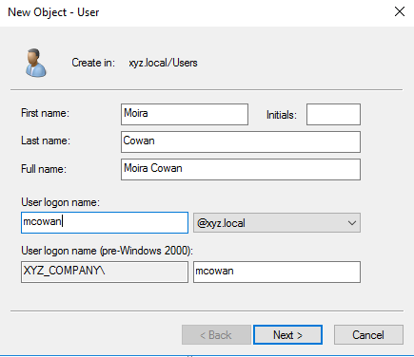
Figure: New User wizard. The Create in: line shows the destination OU.
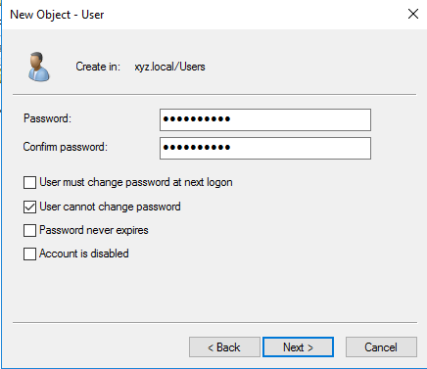
Figure: Setting the initial password and the User cannot change password flag.

2.1.2. Adding Users Information
After creating the basic accounts, we must add specific organizational details to each one. This information is what allows Active Directory to function as a central directory for the whole company. During the lab, we focused on adding job titles and department names to ensure that the "phonebook" aspect of AD was complete
- In the Active Directory Users and Computers console, locate a user like CMedved and right-click the name to select Properties.
- On the General tab, fill in the Telephone number and Description fields according to the project requirements.
- Click the Organization tab. Here, enter the Job Title and Department (for example, Finance).
- Click Apply and then OK. We repeated these steps for all nine users to maintain consistency across the XYZ-DC1 database.
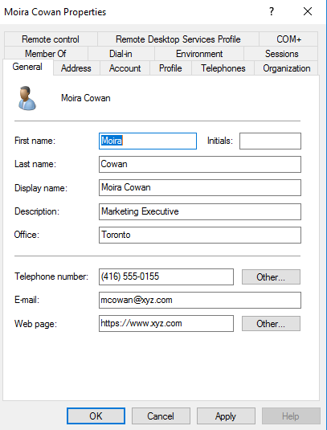
Figure: General tab — display name, description, office, telephone, e-mail, and web page.

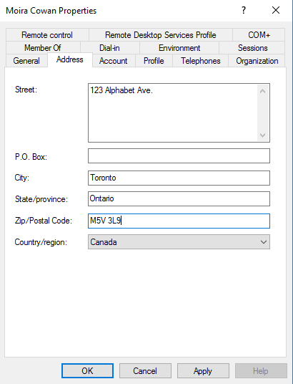
Figure: Address tab — street, city, state, ZIP, and country.
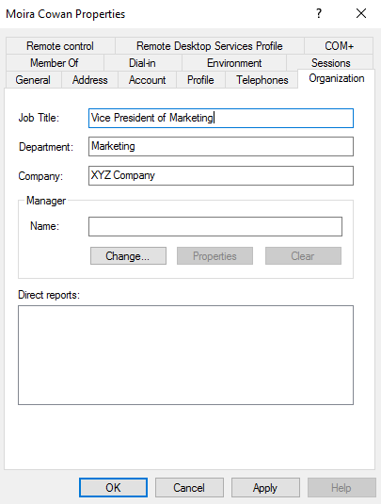
Figure: Organization tab — job title, department, and company.

Logon Hours are set graphically in a 24x7 grid where blue cells mean Logon Permitted and white cells mean Logon Denied. To match the policy of XYZ Company, the entire grid is first set to Logon Denied and then the cells corresponding to Monday through Friday from 7:00 AM to 8:00 PM are switched to Logon Permitted. The same process is applied to every user (a sample for Moira Cowan is shown below).

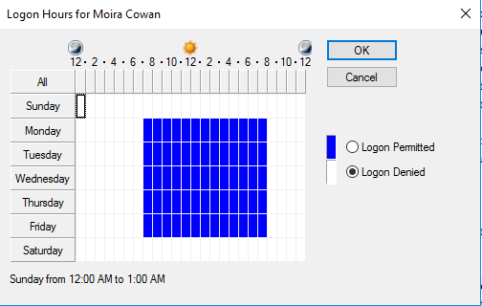
Figure: Logon Hours dialog — Monday through Friday 7:00 AM to 8:00 PM.
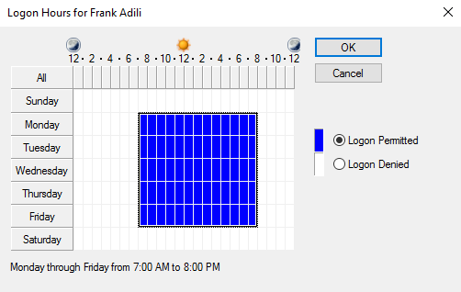
Figure: Same Logon Hours pattern applied to Frank Adili.

Once all nine users are created and their attributes (and Logon Hours) are set, the Users default container shows the complete list of accounts and security groups for the domain.

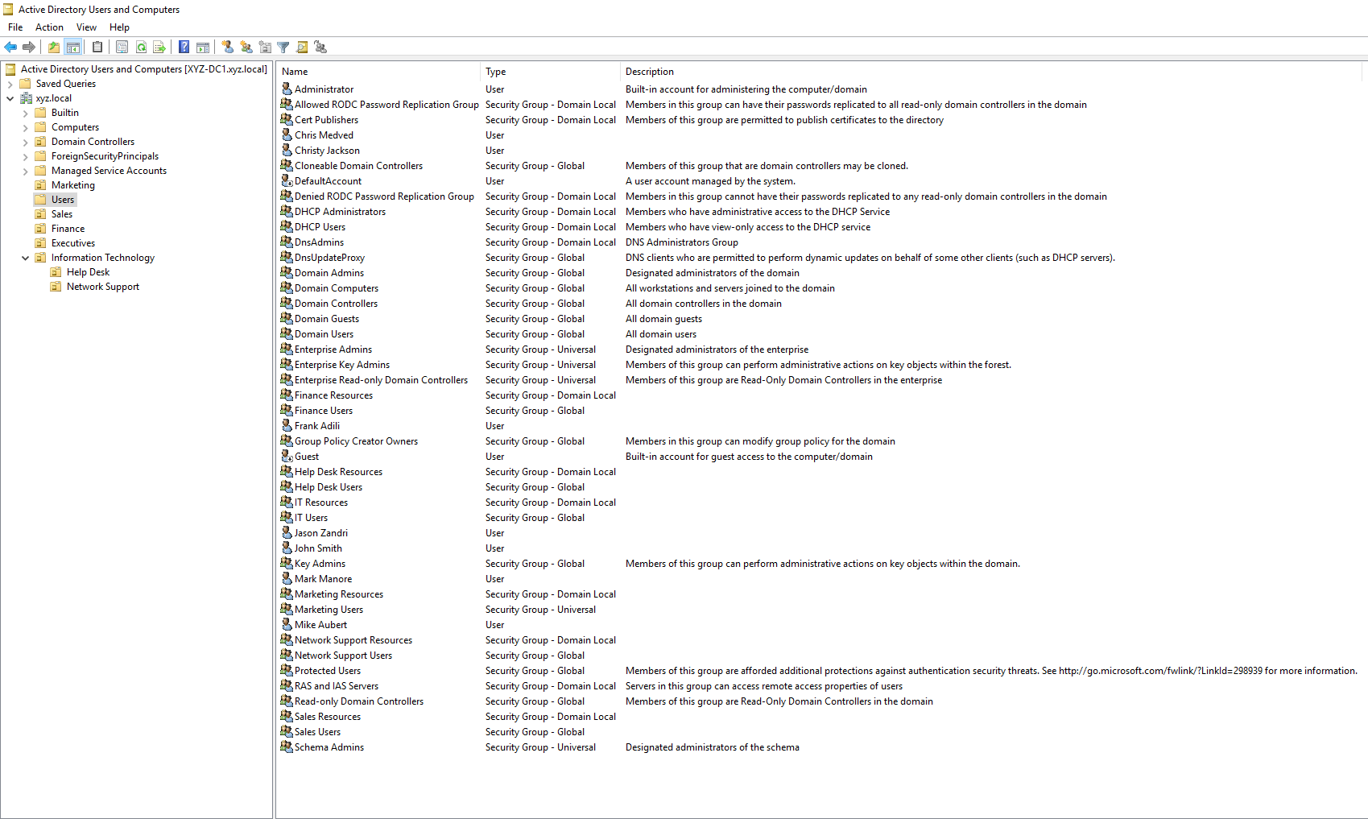
Figure: Active Directory Users and Computers — all nine users and the security groups.

2.2. Groups

Once the users were ready, the next task was to organize them into groups. This makes it much easier to manage permissions later on, especially when we start dealing with file sharing and security policies.

2.2.1. Creating Groups
For this project, we created security groups for each department. Following the specifications from the IT Department, we used the naming convention of the department name followed by "Group."

- In ADUC, right-click the Users folder (or the specific OU if preferred), select New, and then click Group.
- Type the Group name (e.g., Marketing Group).
- Ensure the Group scope is set to Global and the Group type is Security.
- Click OK to finish.

The full table of groups created for the demonstration is reproduced below. After every group is created, its members are added through the Members tab of the group properties dialog.

Group | Scope | Members
Marketing Users | Universal | Moira Cowan, John Harold Smith
Marketing Resources | Domain Local | Marketing Users
Sales Users | Global | Frank Adili, Christy Jackson
Sales Resources | Domain Local | Sales Users
Finance Users | Global | Chris Medved
Finance Resources | Domain Local | Finance Users
IT Users | Global | Mark Manore
IT Resources | Domain Local | IT Users
Help Desk Users | Global | John Smith
Help Desk Resources | Domain Local | Help Desk Users
Network Support Users | Global | Mike Aubert, Jason Zandri
Network Support Resources | Domain Local | Network Support Users
Print Operators (Built-in) | Domain Local | Help Desk Users, IT Users, Network Support Users

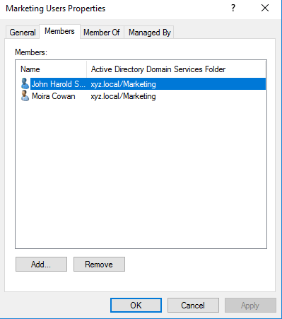
Figure: Marketing Users — Members tab showing Moira Cowan and John Harold Smith.

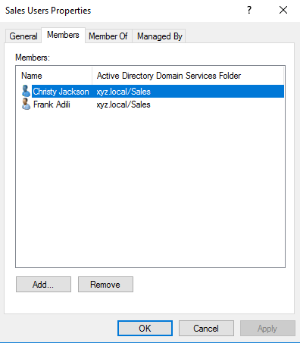
Figure: Sales Users — Frank Adili and Christy Jackson.
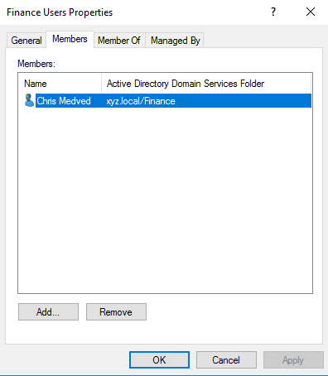
Figure: Finance Users — Chris Medved.

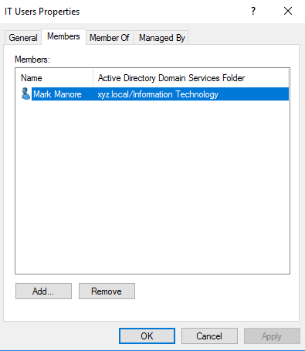
Figure: IT Users — Mark Manore.
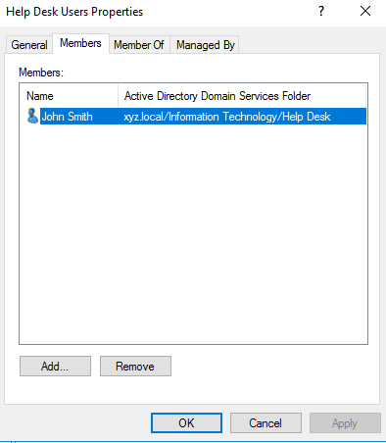
Figure: Help Desk Users — John Smith.
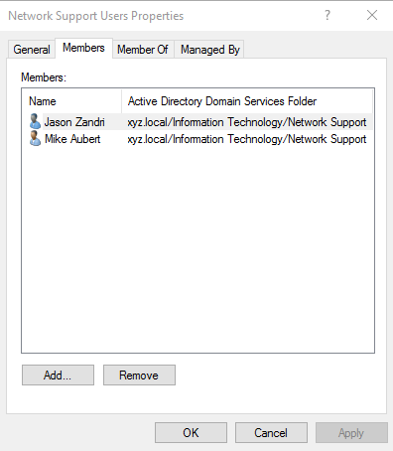
Figure: Network Support Users — Mike Aubert and Jason Zandri.
After all Users groups are filled correctly, make sure each one is added as a member of the corresponding Resources group. This is the A-G-DL-P pattern: User Accounts go into Global groups, Global groups go into Domain Local groups, permissions on resources are then granted to the Domain Local groups.
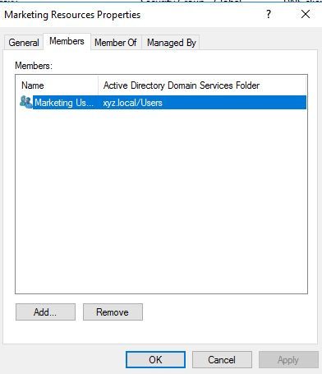
Figure: Marketing Resources contains the Marketing Users group.

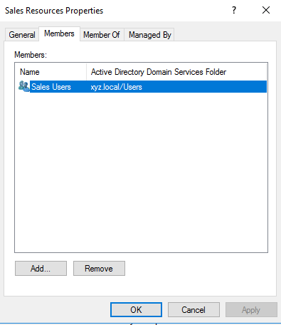
Figure: Sales Resources contains Sales Users.
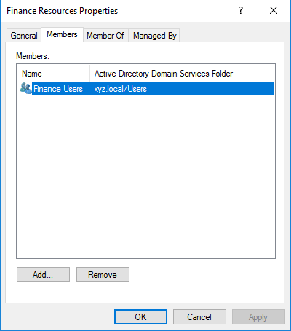
Figure: Finance Resources contains Finance Users.

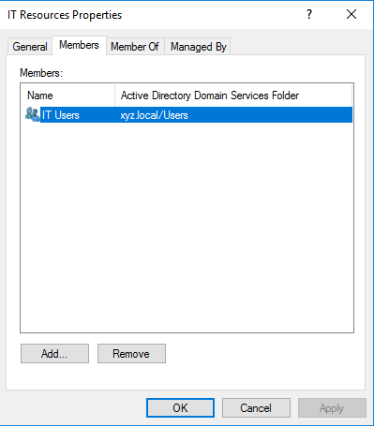
Figure: IT Resources contains IT Users.
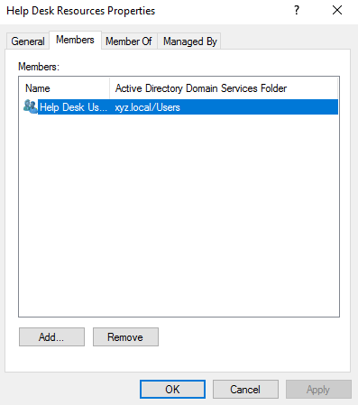
Figure: Help Desk Resources contains Help Desk Users.
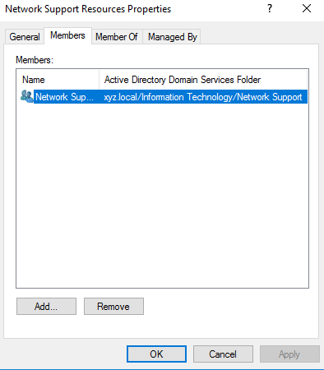
Figure: Network Support Resources contains Network Support Users.

Finally, the Help Desk Users, IT Users, and Network Support Users groups are added as members of the built-in Print Operators group. Print Operators is one of the few groups where members are allowed to log on locally to a Domain Controller, this means that the technical support staff are able to manage the printers attached to the server.

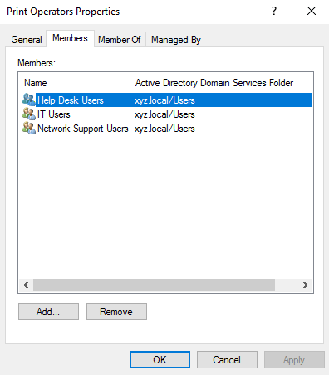
Figure: Print Operators — members from the three technical-support Users groups.

2.2.2. Changing Groups Scope
In some cases, we need to change how a group is recognized within the forest. During our class demonstration, we practiced changing a group from Global to Domain Local to understand how permissions are nested under the AGDLP strategy.
- Right-click the group you just created (e.g., Sales Group) and select Properties.
- Under the General tab, look at the Group scope section.
- Change the selection from Global to Domain Local.
- Click Apply. Note that AD allows this change as long as the group is not a member of another group that would cause a conflict in the hierarchy.
Note: Active Directory restricts which scope changes are allowed depending on the current scope and the membership of the group. A Domain Local group (for instance) can’t be converted directly to Global; it must first be promoted to Universal. The Marketing Users group in this project was changed to Universal to anticipate future multi-domain expansion (Microsoft, n.d.-a.).

2.3. DNS, WINS, and DHCP

A professional network requires more than just user accounts; it needs robust name resolution and automatic IP addressing. In this section, we configure the core network services on XYZ-DC1 to ensure all devices can communicate.

2.3.1. DNS

Domain Name System (DNS) is what translates human-friendly names into IP addresses. Without it, Active Directory would not function because the client computers wouldn't be able to find the domain controller.

2.3.1.1. Creating DNS zones
- Open Server Manager, click Tools, and select DNS.
- In the DNS Manager, expand the XYZ-DC1 server icon.
- Right-click Forward Lookup Zones and select New Zone to launch the wizard.
- On the Welcome screen, click Next.
- Select Primary zone and ensure the box Store the zone in Active Directory is checked. Click Next.
- For the Replication Scope, choose To all DNS servers running on domain controllers in this domain: XYZ.com. Click Next.
- In the Zone Name field, type XYZ.com and click Next.
- In the Dynamic Update screen, select Allow only secure dynamic updates. Click Next.
- Review the summary and click Finish to create the zone.

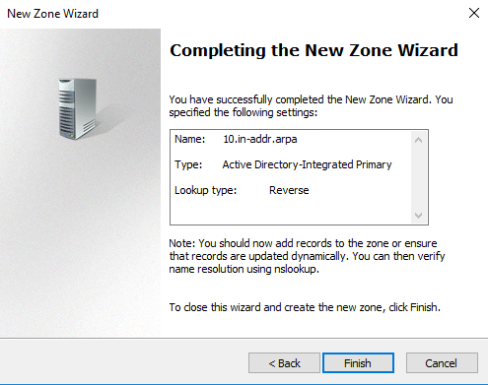
Figure: Reverse zone wizard — 10.in-addr.arpa, AD-integrated, Primary, Reverse.

2.3.1.2. Creating DNS record
Once the forward lookup zone is established, we need to add specific records so the network can locate resources by their names. In our lab, we focused on Host (A) records, which map a hostname to an IPv4 address. We also ensured that a Pointer (PTR) record was created to allow for reverse lookups, which is a common requirement for network security and troubleshooting.In DNS Manager, expand Forward Lookup Zones and click on xyz.local.
- In the DNS Manager, expand the Forward Lookup Zones folder and select the XYZ.com zone we created earlier.
- Right-click an empty area in the right pane and select New Host (A or AAAA).
- In the Name field, type the name of the resource (for example, XYZ-DC1).
- In the IP address field, type the static IP assigned to the server, such as 10.0.0.1.
- Check the box labeled Create associated pointer (PTR) record.
- Click Add Host. A confirmation message will appear stating that the host record was successfully created. Click OK.
- If you need to add more records for other servers or printers in the XYZ Company, repeat these steps for each device.
- Click Done to close the window and verify the new record appears in the zone list.

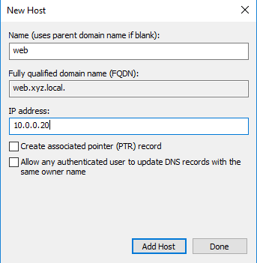
Figure: New Host dialog — web.xyz.local pointing to 10.0.0.20.
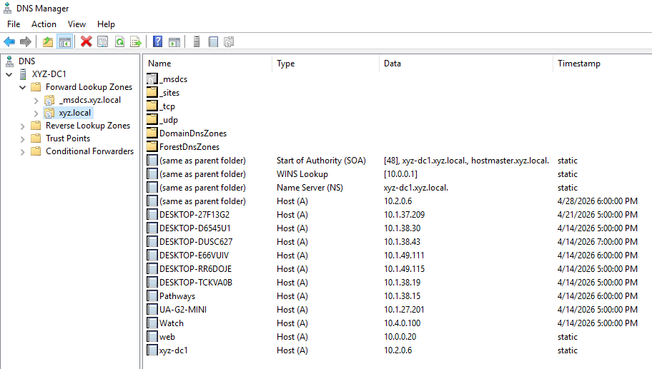
Figure: Forward zone xyz.local with all records, including the new web host and the WINS Lookup record.

2.3.2. WINS

Windows Internet Name Service (WINS) is essential for resolving NetBIOS names to IP addresses, especially in environments with legacy applications. In our XYZ Company setup, we ensure that name resolution is consistent across all protocols.

2.3.2.1. Configuring DNS
- Open Server Manager, click Tools, and select WINS.
- In the WINS console, expand the XYZ-DC1 server node.
- Right-click Active Registrations and select Display Records.
- Click Find Now to verify that the server is successfully capturing NetBIOS names from the local network.
- Let’s make sure there’s availability for a second controller, right-click Replication Partners and select New Replication Partner.
- Type the IP address of the partner server and click OK. For this demonstration, we focused on confirming that XYZ-DC1 handles all local queries.
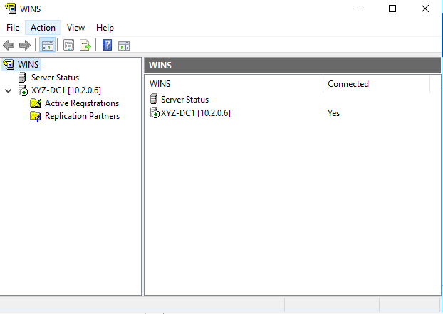
Figure: WINS console — XYZ-DC1 [10.2.0.6] connected.
Inside the DNS zone xyz.local, a WINS Lookup record is created on its own that let DNS query WINS as a fallback when a name can’t be found in the zone. In addition, this integration is visible in the Forward Lookup Zones screenshot above.
The DHCP server is also configured to update DNS records dynamically on behalf of older clients that aren’t able to register themselves. The dynamic update settings are accessed from the IPv4 Properties of the DHCP server, on the DNS tab.

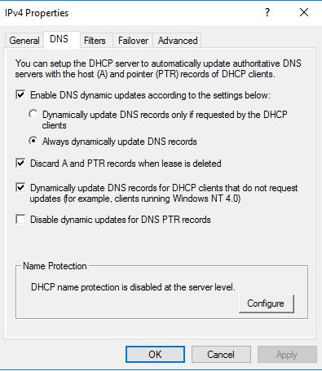

Figure: Dynamic DNS update settings on the DHCP server.

2.3.3. DHCP

The Dynamic Host Configuration Protocol (DHCP) is what allows us to automate IP management. Instead of visiting every desk in the Marketing or Sales departments, the server assigns addresses automatically.

2.3.3.1. Configuring DHCP scope
A scope is the range of IP addresses that DHCP can lease. For XYZ Company, the scope covers the entire 10.0.0.0/8 network, and the first 50 addresses are excluded so they can be reserved for servers, printers, and network equipment.
- Open the DHCP console from the Tools menu.
- Expand XYZ-DC1, right-click IPv4, and select New Scope to start the wizard.
- On the Scope Name screen, type XYZ_Clients and click Next.
- In the IP Address Range screen, enter the following:
- Start IP address: 10.0.0.1
- End IP address: 10.255.255.254
- Length: 8
- Subnet mask: 255.0.0.0
- Click Next. In the Add Exclusions and Delay screen, we must reserve the first 50 addresses for our infrastructure:
- Start IP address: 10.0.0.1
- End IP address: 10.0.0.50
- Click Add, then click Next.
- Set the Lease Duration to the default 8 days and click Next.
- In the Configure DHCP Options screen, select Yes, I want to configure these options now and click Next.
- For the Router (Default Gateway), type 10.0.0.1 and click Add, then Next.
- In the Domain Name and DNS Servers screen, verify XYZ.com is the parent domain and 10.0.0.1 is listed as the DNS server. Click Next.
- Skip the WINS Server screen by clicking Next, then select Yes, I want to activate this scope now.
- Click Finish.

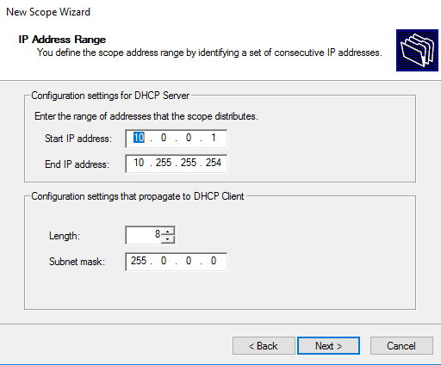
Figure: IP Address Range — 10.0.0.1 to 10.255.255.254 with /8 mask.

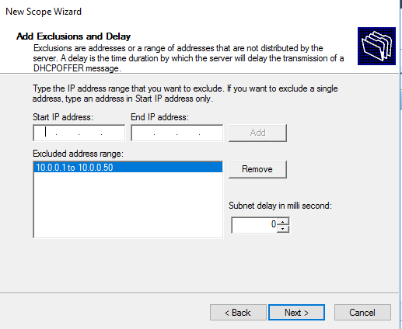
Figure: Exclusion 10.0.0.1 to 10.0.0.50 reserves the first 50 addresses for static use.

2.3.3.2. Configuring reservations
A reservation guarantees that a specific computer always receives the same IP address from DHCP, identified by its MAC address. In this case, we need to make two reservations: Finance-DB and IT-Fileserver. Reservations are created inside the scope, after the scope is activated.
- In the DHCP console, expand the new XYZ_Clients scope.
- Right-click Reservations and select New Reservation.
- In the Reservation name field, type a descriptor like Manager-PC.
- Assign a specific IP address (for example, 10.0.0.100).
- Enter the MAC address of the target device without dashes or colons.
- Under Supported types, leave Both selected and click Add.
- Click Close and verify the reservation appears in the list.

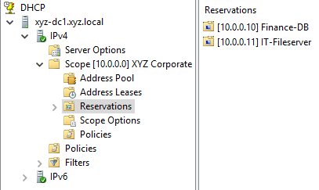
Figure: Reservations branch with Finance-DB (10.0.0.10) and IT-Fileserver (10.0.0.11).

2.4. Computers

In an Active Directory environment, computers must be joined to the domain to be managed by Group Policies. For the XYZ Company demonstration, we decided to pre-create the computer objects in their respective Organizational Units (OUs). This practice ensures that as soon as a physical workstation joins the domain, it immediately falls under the correct departmental policies without manual moving.

2.4.1. Creating Computers
To register the workstations in our database, we used the Active Directory Users and Computers console. We followed a naming convention based on the department and workstation number to keep the inventory organized.
- Open Server Manager, click Tools, and select Active Directory Users and Computers.
- Navigate through the XYZ.com domain and locate the specific OU where the computer will reside (for example, the Marketing OU).
- Right-click an empty space in the right pane, select New, and then click Computer.
- In the Computer name field, type the designation for the machine, such as MARKETING-WS1.
- Verify that the Computer name (pre-Windows 2000) field is filled automatically with the same name.
- Under the User or group section, you will see who is allowed to join this computer to the domain. By default, this is set to Domain Admins, which is what we used for our lab.
- Click OK. The computer object will now appear in the OU with a computer icon, ready for the physical machine to be joined to the XYZ-DC1 controller.

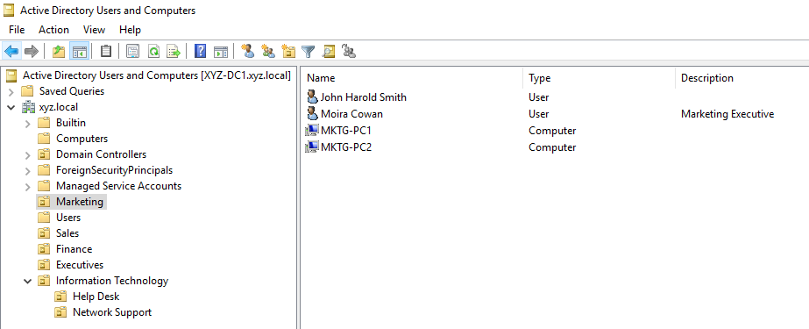
Figure: Marketing OU contains MKTG-PC1, MKTG-PC2, Moira Cowan, and John Harold Smith.

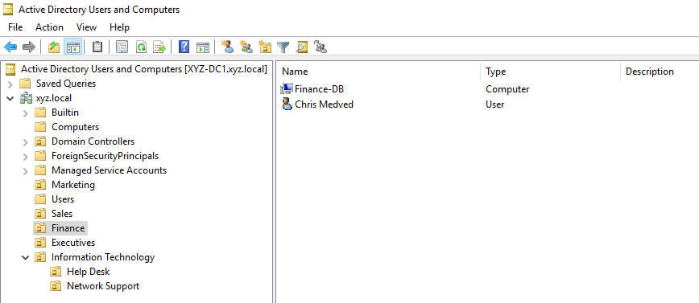
Figure: Finance OU contains Finance-DB and Chris Medved.
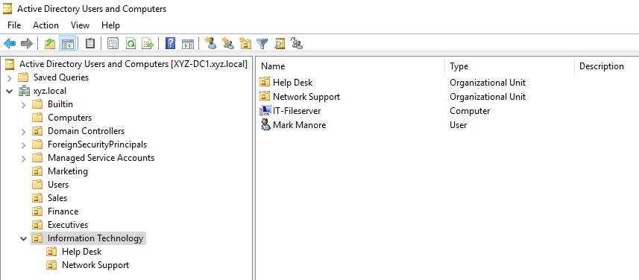
Figure: Information Technology OU with the sub-OUs Help Desk and Network Support, plus the IT-Fileserver computer and Mark Manore.
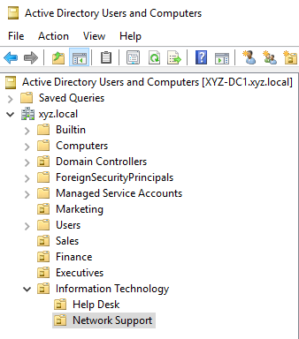
Figure: Complete OU hierarchy of the xyz.local domain.

2.5. Group Policy

Group Policy implementation is where we enforce the company's operating policies. For this project, we organized our resources into Organizational Units (OU’s) to ensure that policies only affect the intended users and computers on XYZ-DC1.

2.5.1. Linking Policies
Before a policy can take effect, it must be linked to a specific container. In our lab, we linked department-specific rules to their respective OUs. From the desktop, open Server Manager > Tools > Group Policy Management.
- Open Group Policy Management from the Tools menu in Server Manager.
- Expand Forest: XYZ.com > Domains > XYZ.com.
- Right-click the desired OU (for example, Marketing) and select Create a GPO in this domain, and Link it here....
- Name the GPO (e.g., Marketing_Policy) and click OK.
- The new GPO will now appear linked to the OU, marked with a shortcut icon.

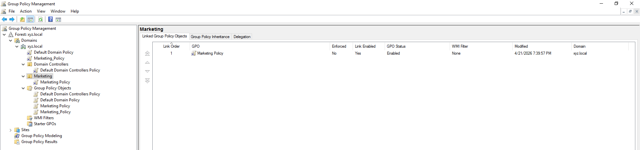
Figure: Marketing OU with Marketing Policy linked, Link Enabled = Yes, GPO Status = Enabled.

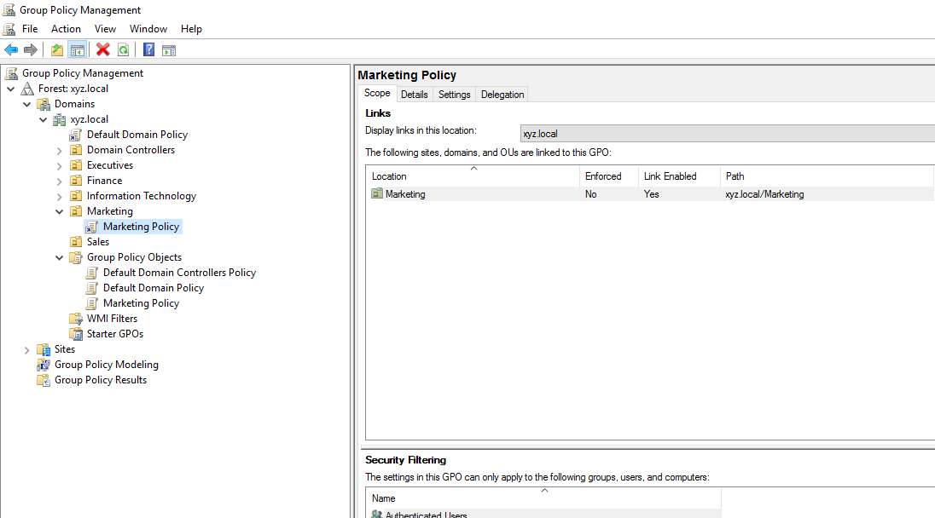
Figure: Marketing Policy — Scope tab confirms the link to xyz.local/Marketing.

2.5.2. Creating General Policies
These settings focus on the user’s interface and environment restrictions.
- In Group Policy Management, right-click your new GPO (Marketing_Policy) and select Edit.
- To restrict the Control Panel, navigate to User Configuration > Policies > Administrative Templates > Control Panel.
- Double-click Prohibit access to Control Panel and PC settings.
- Select Enabled, then click Apply and OK.
- To set the departmental wallpaper, navigate to User Configuration > Policies > Administrative Templates > Desktop > Desktop.
- Edit the Desktop Wallpaper setting, set it to Enabled, and provide the local or network path to the image file.

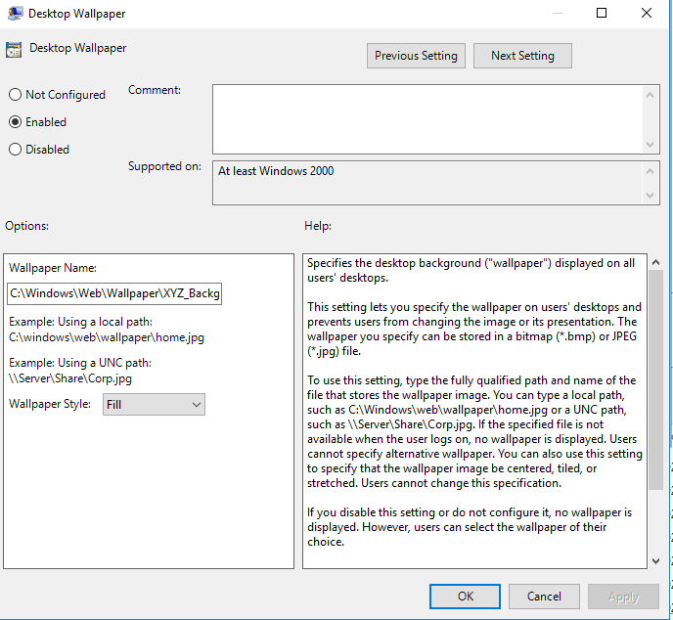
Figure: Desktop Wallpaper — Enabled, full path, Fill style.
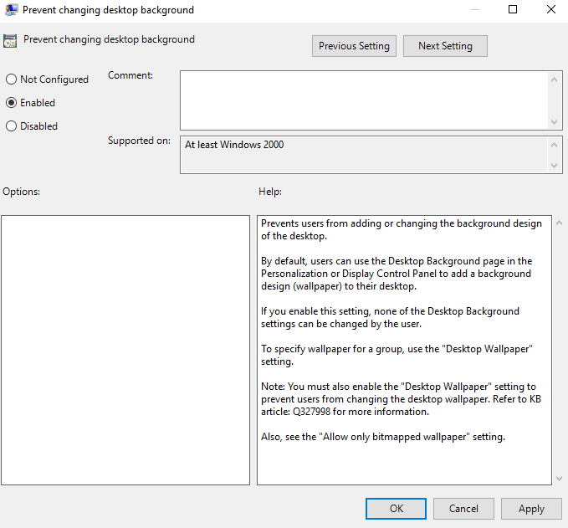
Figure: Prevent changing desktop background — Enabled.
We also used the Administrative Templates to further customize the user experience and improve security by removing unnecessary icons and menus.
- In the same Desktop folder within Administrative Templates, locate and double-click Remove Recycle Bin icon from desktop. Select Enabled and click OK.
- Navigate to User Configuration > Policies > Administrative Templates > Start Menu and Taskbar.
- Double-click Remove Documents icon from Start Menu, select Enabled, and click OK.
- In the same folder, locate Remove Run menu from Start Menu. Set this to Enabled to prevent users from executing unauthorized commands.
- To keep the interface clean, double-click Remove user name from Start Menu, select Enabled, and click Apply.

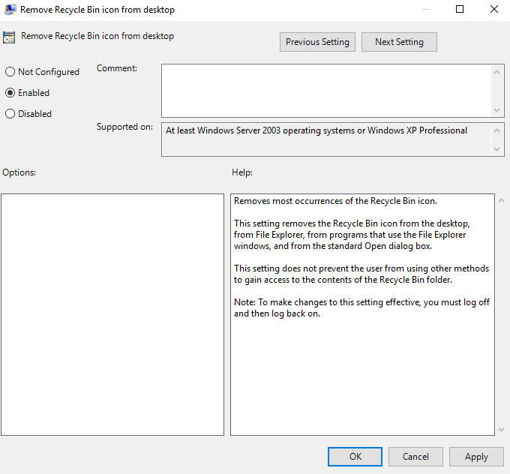
Figure: Remove Recycle Bin icon from desktop — Enabled.
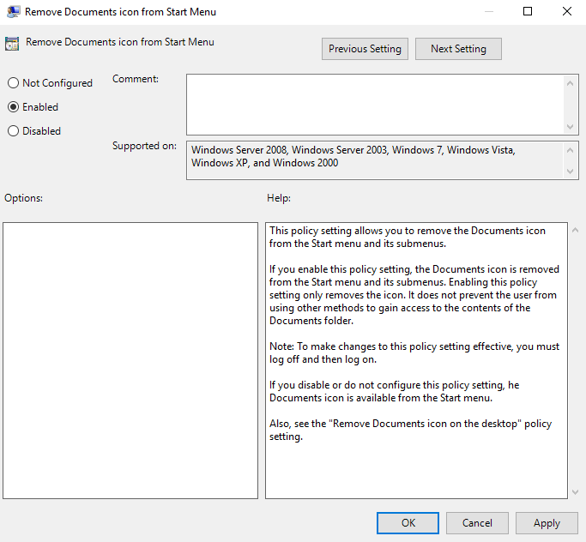
Figure: Remove Documents icon from Start Menu — Enabled.

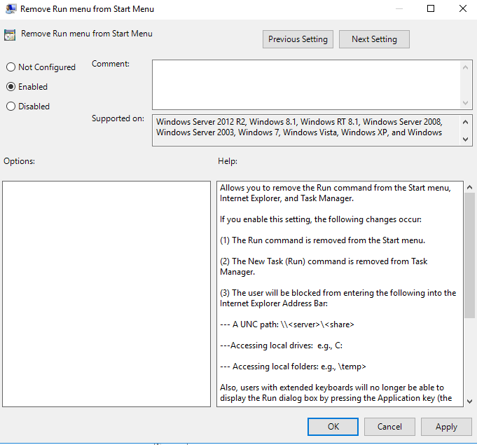
Figure: Remove Run menu from Start Menu — Enabled.
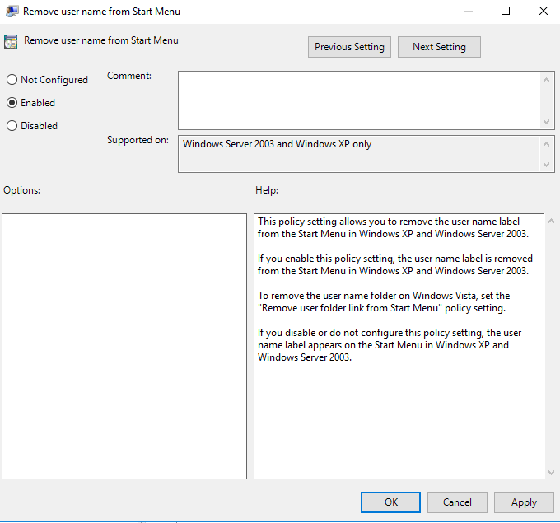
Figure: Remove user name from Start Menu — Enabled.
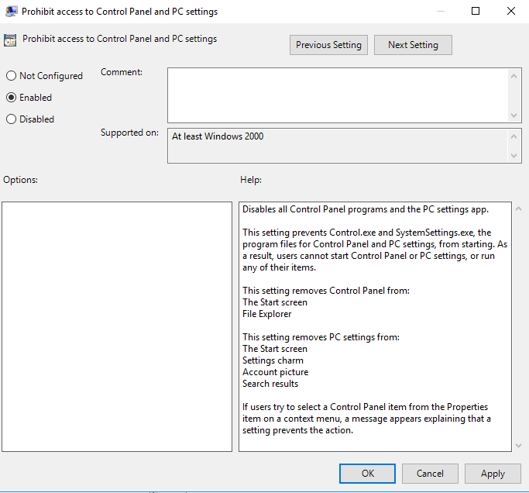
Figure: Prohibit access to Control Panel and PC settings — Enabled.

2.5.3. Creating Security Policies
Security policies protect the domain by enforcing rules like password complexity and login behavior. We also configured lockout restrictions to prevent unauthorized access through multiple failed login attempts.
- In the GPO Editor, navigate to Computer Configuration > Policies > Windows Settings > Security Settings.
- Expand Account Policies > Password Policy.
- Double-click Minimum password length and set it to 7 characters. Click OK.
- To improve login security, go to Local Policies > Security Options and enable the policy Interactive logon: Do not display last user name.
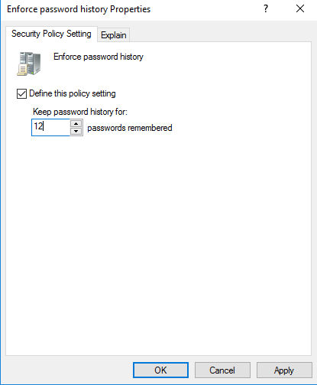
Figure: Enforce password history — 12 passwords remembered.
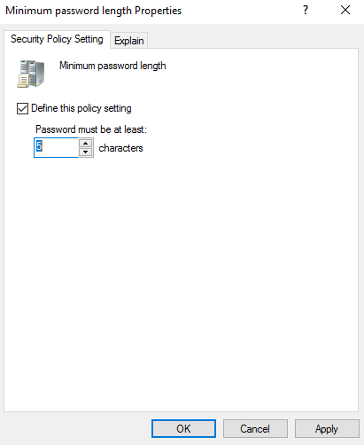
Figure: Minimum password length — 5 characters.
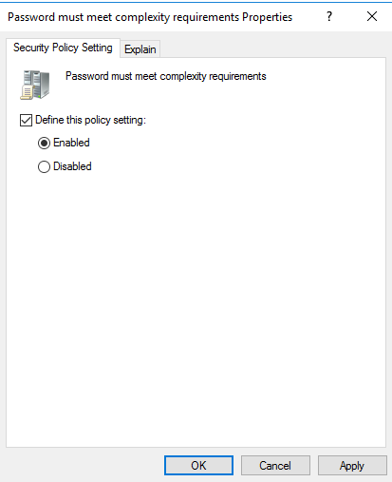
Figure: Password must meet complexity requirements — Enabled.
Account Lockout Policy Configuration:
To secure the XYZ Company against brute-force attacks, we established strict lockout thresholds.
- In the same Account Policies branch, select the Account Lockout Policy folder.
- Double-click Account lockout threshold. Set the value to 3 invalid logon attempts and click OK.
- A dialog box will appear suggesting default values for the duration and the reset counter. We adjusted these according to the project requirements:
- Set the Account lockout duration to 15 minutes.
- Set the Reset account lockout counter after to 5 minutes.
- Click Apply and OK to commit the security changes to the GPO.

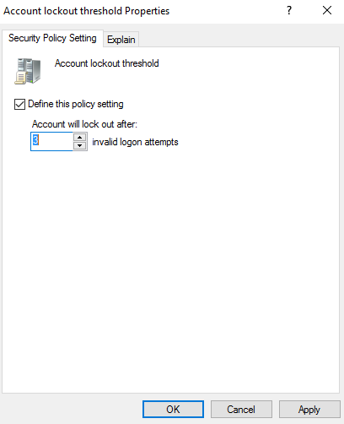
Figure: Account lockout threshold — 3 invalid logon attempts.
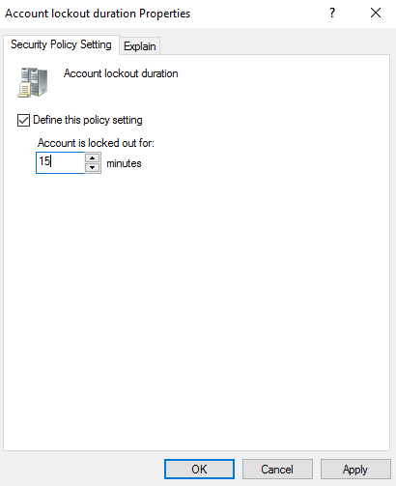
Figure: Account lockout duration — 15 minutes.
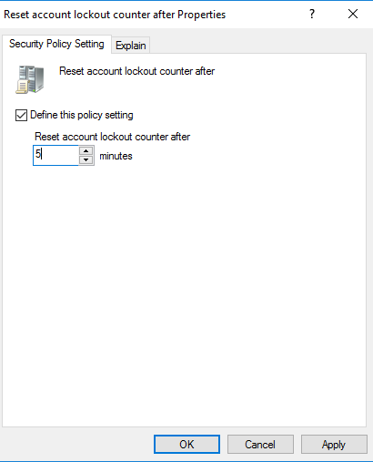
Figure: Reset account lockout counter after — 5 minutes.

Interactive Logon Banner Configuration:
To comply with the XYZ Company Security Policy, we configured a legal notice that appears every time a user attempts to log on to a workstation. This ensures all employees are aware of the system's usage terms.
- In the same Security Options folder (located under Local Policies), find the policy titled Interactive logon: Message text for users attempting to log on.
- Double-click the policy and check the box for Define this policy setting.
- In the text box provided, type the official security policy message (e.g., "This system is for authorized XYZ Company use only"). Click OK.
- Additionally, locate the policy Interactive logon: Message title for users attempting to log on.
- Enable it and type a title such as Security Notice or Authorized Access Only to ensure the banner is presented clearly.
- Click Apply and OK.
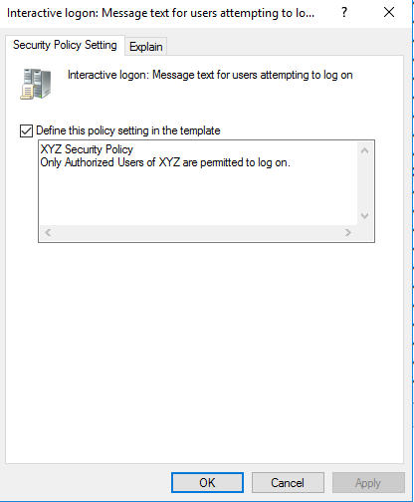
Figure: Interactive logon message — XYZ Security Policy.

2.5.4. Managing File System Permissions
We can also use Group Policy to secure specific folders on the server's hard drive automatically.
- Navigate to Computer Configuration > Policies > Windows Settings > Security Settings > File System.
- Right-click and select Add File....
- Browse to the folder you want to secure (e.g., a shared folder for the Sales department).
- In the security dialog, add the Sales Group and assign the necessary permissions like Read and Write.
- Click OK and choose the option to propagate these permissions to all subfolders.
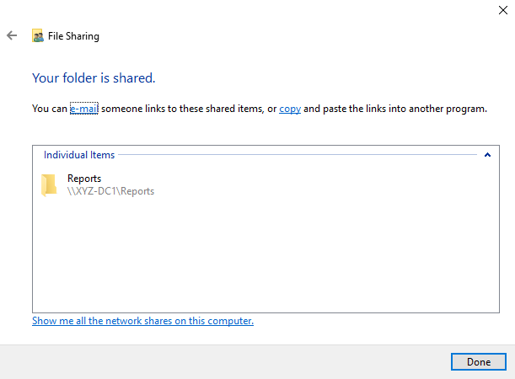
Figure: File Sharing dialog — Reports folder shared as \\XYZ-DC1\Reports.
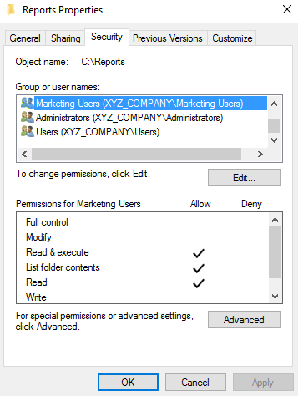
Figure: Security tab on C:\Reports — Marketing Users with Read & execute, List, Read.

2.5.5. Software Deployment
Finally, we use GPOs to automate the installation of essential tools like 7-Zip across the XYZ Company.
- Ensure the 7-Zip.msi file is in a shared network folder where "Everyone" has Read access.
- In the GPO Editor, go to Computer Configuration > Policies > Software Settings.
- Right-click Software installation, select New, and then Package.
- Type the full network path (UNC) to the file, such as \\XYZ-DC1\Deploy\7zip.msi, and click Open.
- Select Assigned and click OK. The software will be installed the next time the computer starts up.

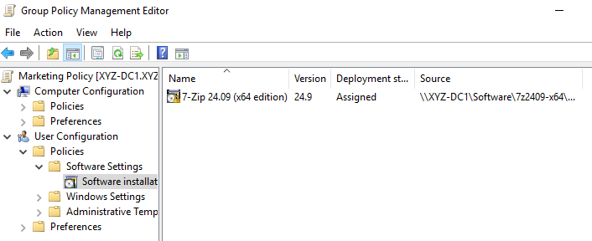
Figure: Software installation — 7-Zip 24.09 (x64 edition) Assigned, single deployment, sourced from \\XYZ-DC1\Software\7z2409-x64.msi.

2.6. Validating the Implementation
After completing the configuration of users, groups, and policies on XYZ-DC1, we must perform a series of tests to ensure the network is operational. Validation is the final step to confirm that the security settings and network services are being pushed correctly to the workstations.

2.6.1. Using GPUpdate and GPResult
To avoid waiting for the automatic refresh cycle of the Active Directory, we manually forced the application of the Group Policy Objects (GPOs).
- Open the Command Prompt with Administrator privileges.
- Type gpupdate /force and press Enter. This ensures that both Computer and User policies are updated immediately.
- Once the process is finished, type gpresult /r to view the Resultant Set of Policy (RSoP) report.
- In the output, locate the Applied Group Policy Objects section. We verified that our specific policies, such as the Marketing_Policy, were listed as successfully applied.

2.6.1. Using GPUpdate and GPResult
We conducted tests to ensure that name resolution and IP addressing were functioning as intended for XYZ Company.
- DNS Test: In the command prompt, we used the command nslookup XYZ-DC1. The server successfully resolved the name to the static IP 10.0.0.1, confirming the Forward Lookup Zone is healthy.
- DHCP Test: We accessed the DHCP Console and checked the Address Leases folder. We confirmed that client machines were receiving dynamic IP addresses within the permitted range (starting from 10.0.0.51), effectively skipping the exclusion range we set earlier.

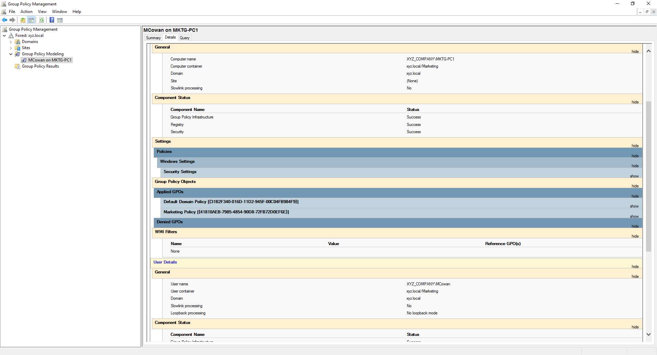
Figure: Modeling result for MCowan on MKTG-PC1 — Marketing Policy listed in Applied GPOs and all components show Success.
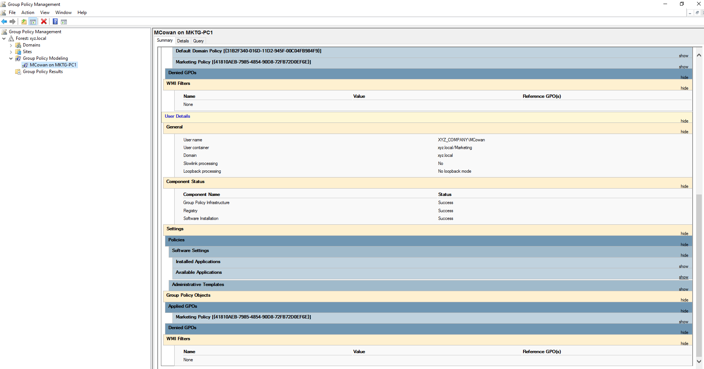
Figure: Modeling — Settings tab confirms Software Installation, Group Policy Objects, and Applied GPOs.

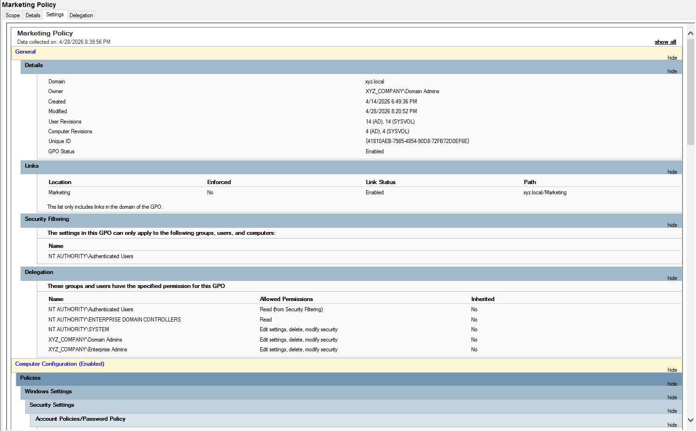
Figure: Marketing Policy Settings report — General details, Links, Security Filtering, and Delegation.

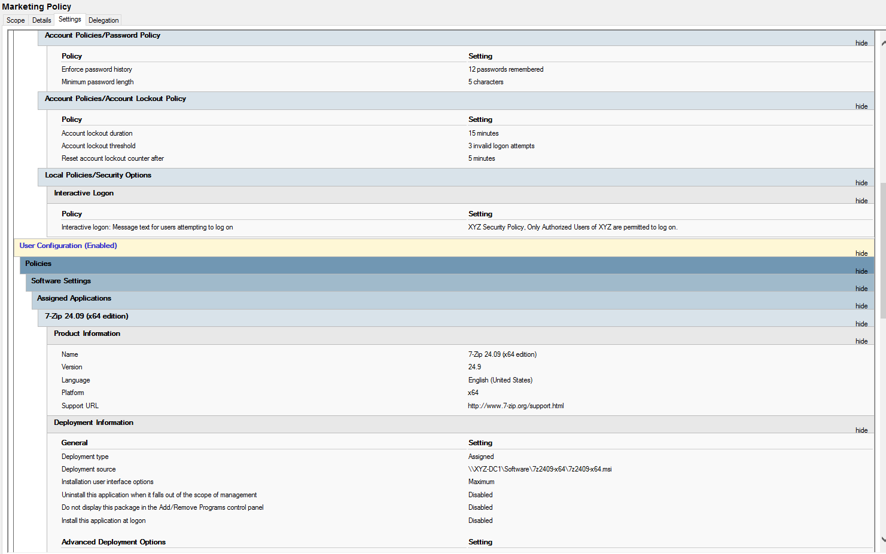
Figure: Marketing Policy Settings report — Account Policies, Local Policies, and Software Settings.

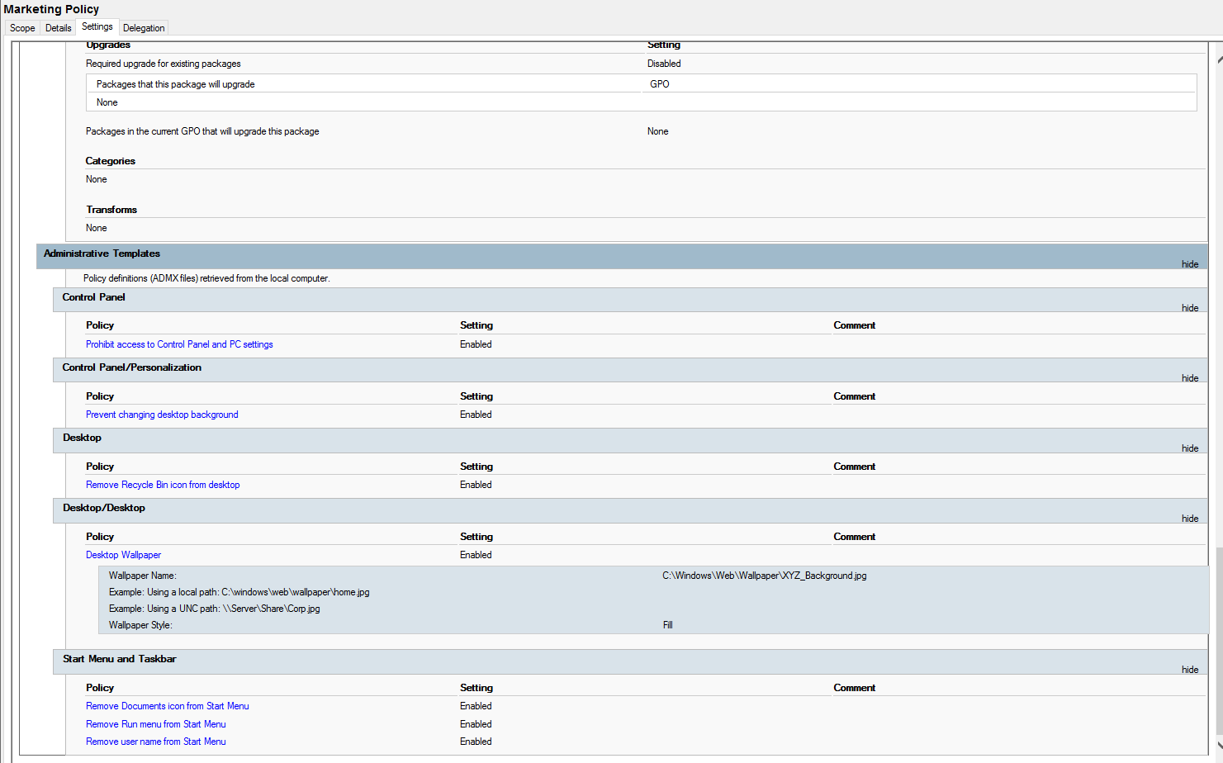
Figure: Marketing Policy Settings report — Administrative Templates including Desktop Wallpaper.

Confirmation of the GPO refresh is captured at the Administrator command prompt:
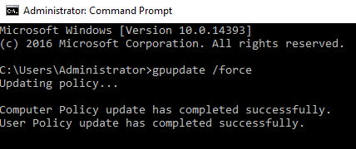
Figure: gpupdate /force — Computer Policy and User Policy updated successfully.

3. References

DiNicolo, D. (2003). Hands-on Microsoft Windows Server 2003
administration. Cengage Learning.

Microsoft. (n.d.-a). Active Directory Domain Services overview.
Microsoft Learn. Retrieved May 2026, from
https://learn.microsoft.com/en-us/windows-server/identity/ad-ds/
get-started/virtual-dc/active-directory-domain-services-overview

Microsoft. (n.d.-b). Active Directory security groups.
Microsoft Learn. Retrieved May 2026, from
https://learn.microsoft.com/en-us/windows-server/identity/ad-ds/
manage/understand-security-groups

Microsoft. (n.d.-c). Group Policy overview for Windows Server.
Microsoft Learn. Retrieved May 2026, from
https://learn.microsoft.com/en-us/windows-server/identity/ad-ds/
manage/group-policy/group-policy-overview

Microsoft. (n.d.-d). DHCP Server role documentation.
Microsoft Learn. Retrieved May 2026, from
https://learn.microsoft.com/en-us/windows-server/networking/
technologies/dhcp/dhcp-top

Microsoft. (n.d.-e). DNS Server role documentation.
Microsoft Learn. Retrieved May 2026, from
https://learn.microsoft.com/en-us/windows-server/networking/
dns/dns-top

Tomsho, G. (2017). Hands-on Microsoft Windows Server 2016.
Cengage Learning.

